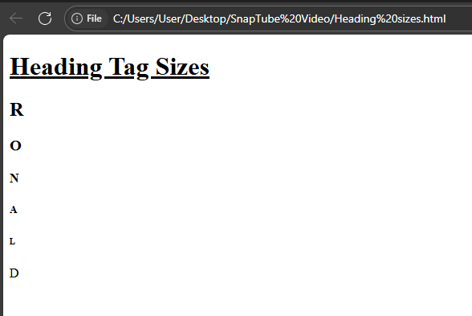
<!DOCTYPE html>
<html>
<head><title>Heading TAG</title></head>
<h1><u>Heading Tag Sizes</u></h1>
<body>
<p>
<h2>R</h2> <h3>O</h3><h4>N</h4> <h5>A</h5> <h6>L</h6><h7>D</h7>

</p>
</body>
</html>

